# Installing DeepLabCut

This step can be a little tricky but please don’t let it put you off! Installing DeepLabCut involves using python, and if you are not used to this it can be intimidating. Stick with it. Once it is downloaded, things get easier! This will walk you through how to download the CPU version of DeepLabCut. This version should load on virtually any computer, regardless of it’s computational power.

**Step 1: Installing Anaconda**

The first step is to instal python. The easiest way to do this is by using a programme called Anaconda. Anaconda basically downloads and installs a bunch of super helpful packages for you, making python easier to use.

<https://www.anaconda.com/products/individual#Downloads>

Use that link and download the one suitable for your computer. For windows, you generally want “64-Bit Graphical Installer”.

**(Step 1.2: Opening Python/Anaconda)**

Anaconda will download a few different programmes and ways to use DeepLabCut onto your computer. I find for DeepLabCut the easiest to use is “anaconda prompt” . Shut down all it opens when you download anaconda, it is way beyond what you need to use anaconda for. Instead, type “Anaconda” into your computer search bar. You should see this:

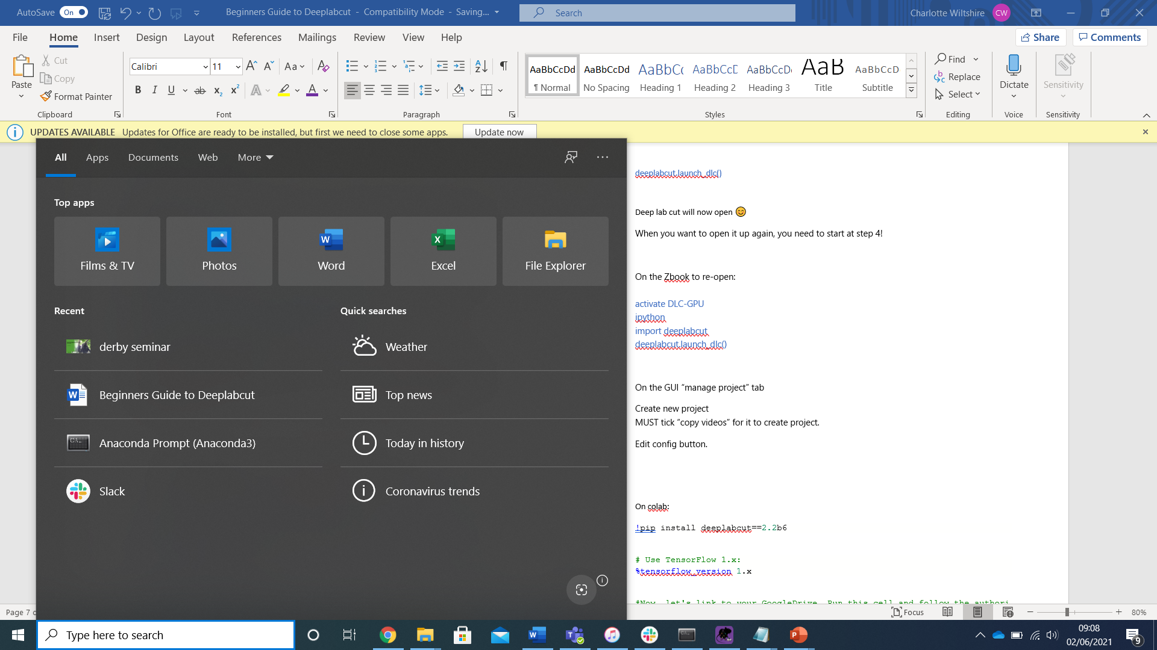

**Step 2: Setting up a DeepLabCut environment**

This step basically stops you from messing about with important things on your computer. When you set up an environment, it means anything you do stays within this environment, and you don’t accidentally end up messing with files you shouldn’t. You will need to download the DEEPLABCUT.yaml from DeepLabCut’s website. Download the file and put it on your desktop

<http://www.mackenziemathislab.org/deeplabcutblog/2021/6/30/tensorflow-2x-is-the-new-default-in-deeplabcut>

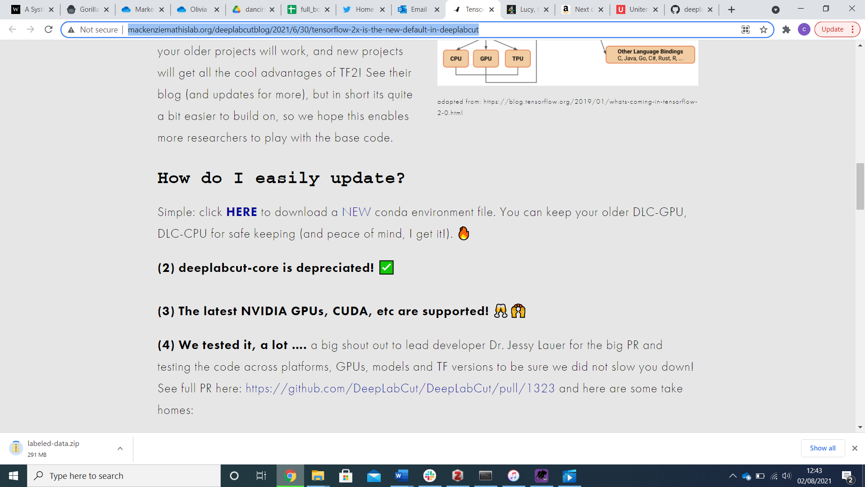

Now the file is on your desktop, you need to let anaconda know where to look for it. Change your working directioy.

cd “enter file path here”

Your file path is usually C:/Users/*your name on your computer*/Desktop  
Or if on a mac /Users/*your name on your computer*/Desktop

conda env create -f DEEPLABCUT.yaml

This will download deeplabcut!

**Step 3: Activate DeepLabCut environment**

**You need to activate the environment. This means you are now working within it.**

activate DEEPLABCUT

You will know if this step has worked because the left-hand side of your anaconda will change.

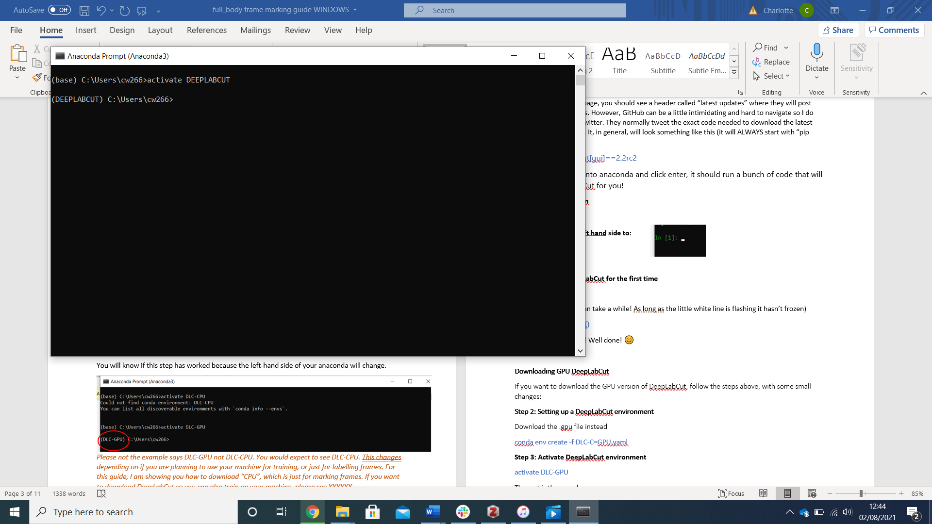

**Step 4: Installing DeepLabCut**

DeepLabCut is constantly updating, and it is really important you download the latest version and regularly check for updates. How to update can be found bellow. I honestly find the easiest way to find the latest version is on their twitter (@DeepLabCut), and this is a great way to stay up to date with when the software needs updating.   
They also regularly update their GitHub, so if you are not on twitter check here:  
<https://github.com/DeepLabCut/DeepLabCut>  
If you scroll down the page, you should see a header called “latest updates” where they will post about versions/updates. However, GitHub can be a little intimidating and hard to navigate so I do suggest just checking twitter. They normally tweet the exact code needed to download the latest version of DeepLabCut. It, in general, will look something like this (it will ALWAYS start with “pip install”):

pip install deeplabcut[gui]==2.2rc2

Once you type that into anaconda and click enter, it should run a bunch of code that will download DeepLabCut for you!

**Step 5: Loading ipython**

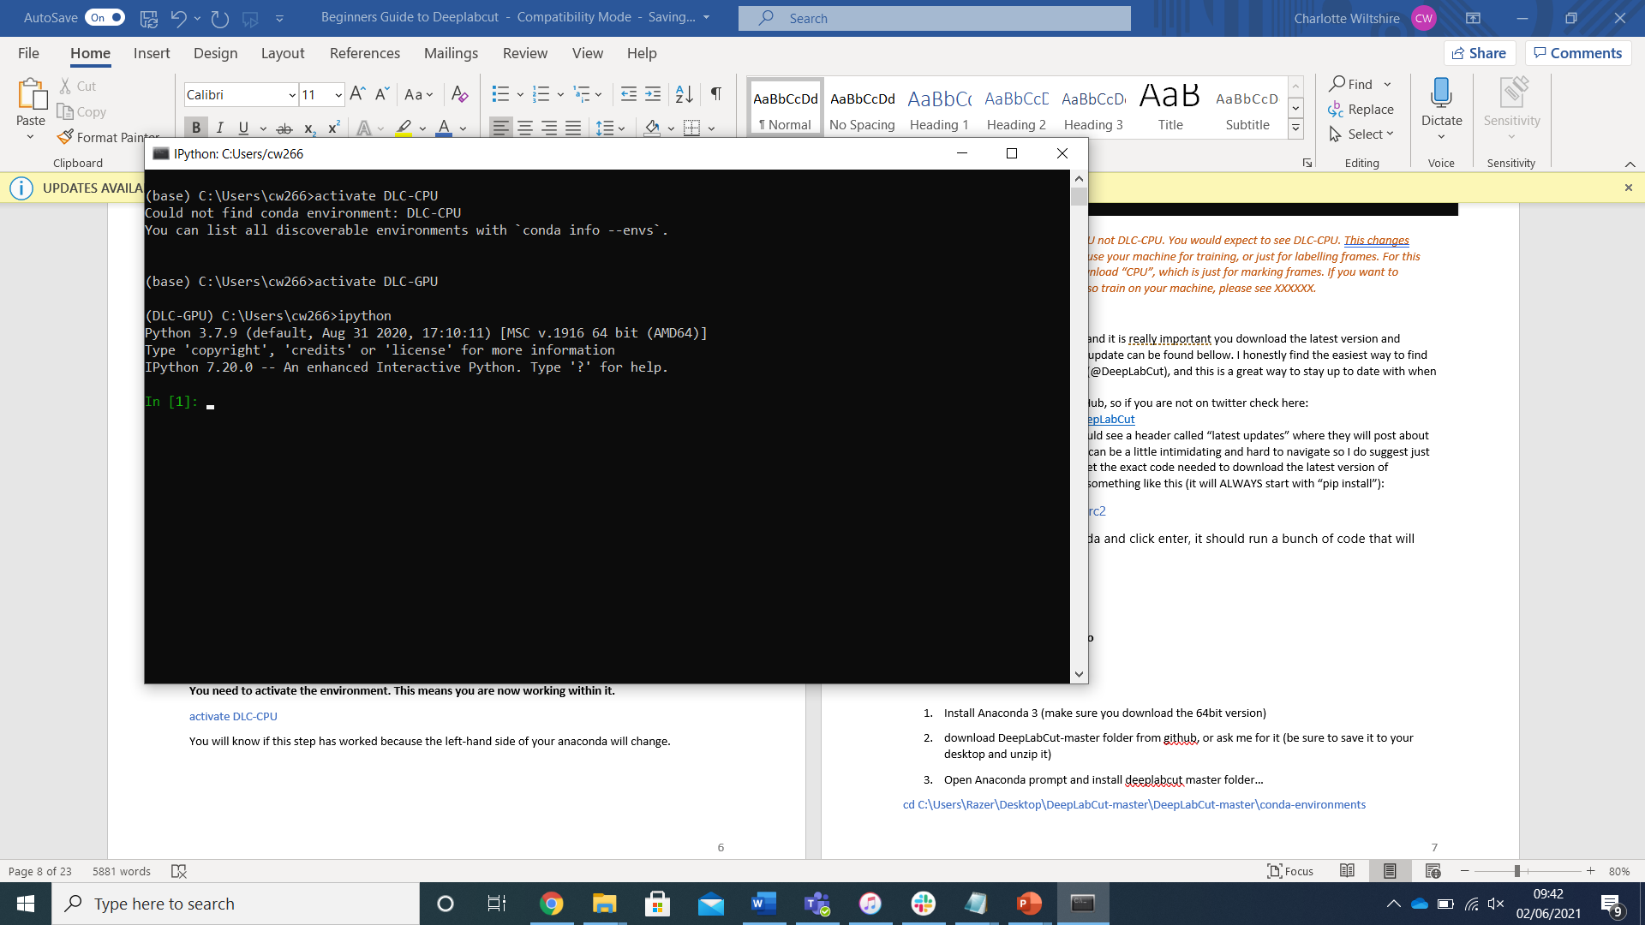ipython

**This will change the left hand side to:**

**Step 6: Opening DeepLabCut for the first time**

Import DEEPLABCUT

(be patient, this step can take a while! As long as the little white line is flashing it hasn’t frozen)

Deeplabcut.launch_dlc()

The GUI will now open! Well done! 😊